New Event Coming to DC-G IN 2020!!!
Goal: 70 cakes
What: Athletic Booster Cake Auction
Where: Meadows Commons and Gym
When: Friday, February 14th, 2020 - Norwalk @ DCG Basketball Game
Time: Live Auction Times – Girls Halftime (6:40pm) Silent Auction – 5pm-8:30pm
In-between games (7:15pm) Cake and Ice Cream Social 5pm
Boys Halftime (8:15pm)
How do we participate????
Cake theme: I DC-G!!! (Add your group to the end!)
Cake Registration begins at 4pm on February 14th in Meadows.
All athletic programs WILL have a cake submitted to the cake auction. Other Clubs and Activities are encouraged to get in on the fun and promote your Club or Activity. Elementary, MS, HS Classrooms, Youth Groups, Club Teams, and PTO’s also make this event fun!!!

3 Divisions for judging determined by WHO made the cake: Professional, Amateur, Student/Staff/Team. 1ST, 2ND, 3RD, AND HONORABLE MENTION RIBBONS!!

Different ways to enter a cake:
- Your group collects money from members and has a Professional make your theme cake and decorate. This cake goes in the Professional Division.
- Your group gets together and makes their own theme cake and decorates. This cake goes in the Student/Staff/Team Division. Winning classroom cake receives a $100 gift card from the Boosters too Staples (Elem, MS, HS classrooms all eligible!!!)
- This cake was made by a professional for a high school softball team. It sold for $1,000!!
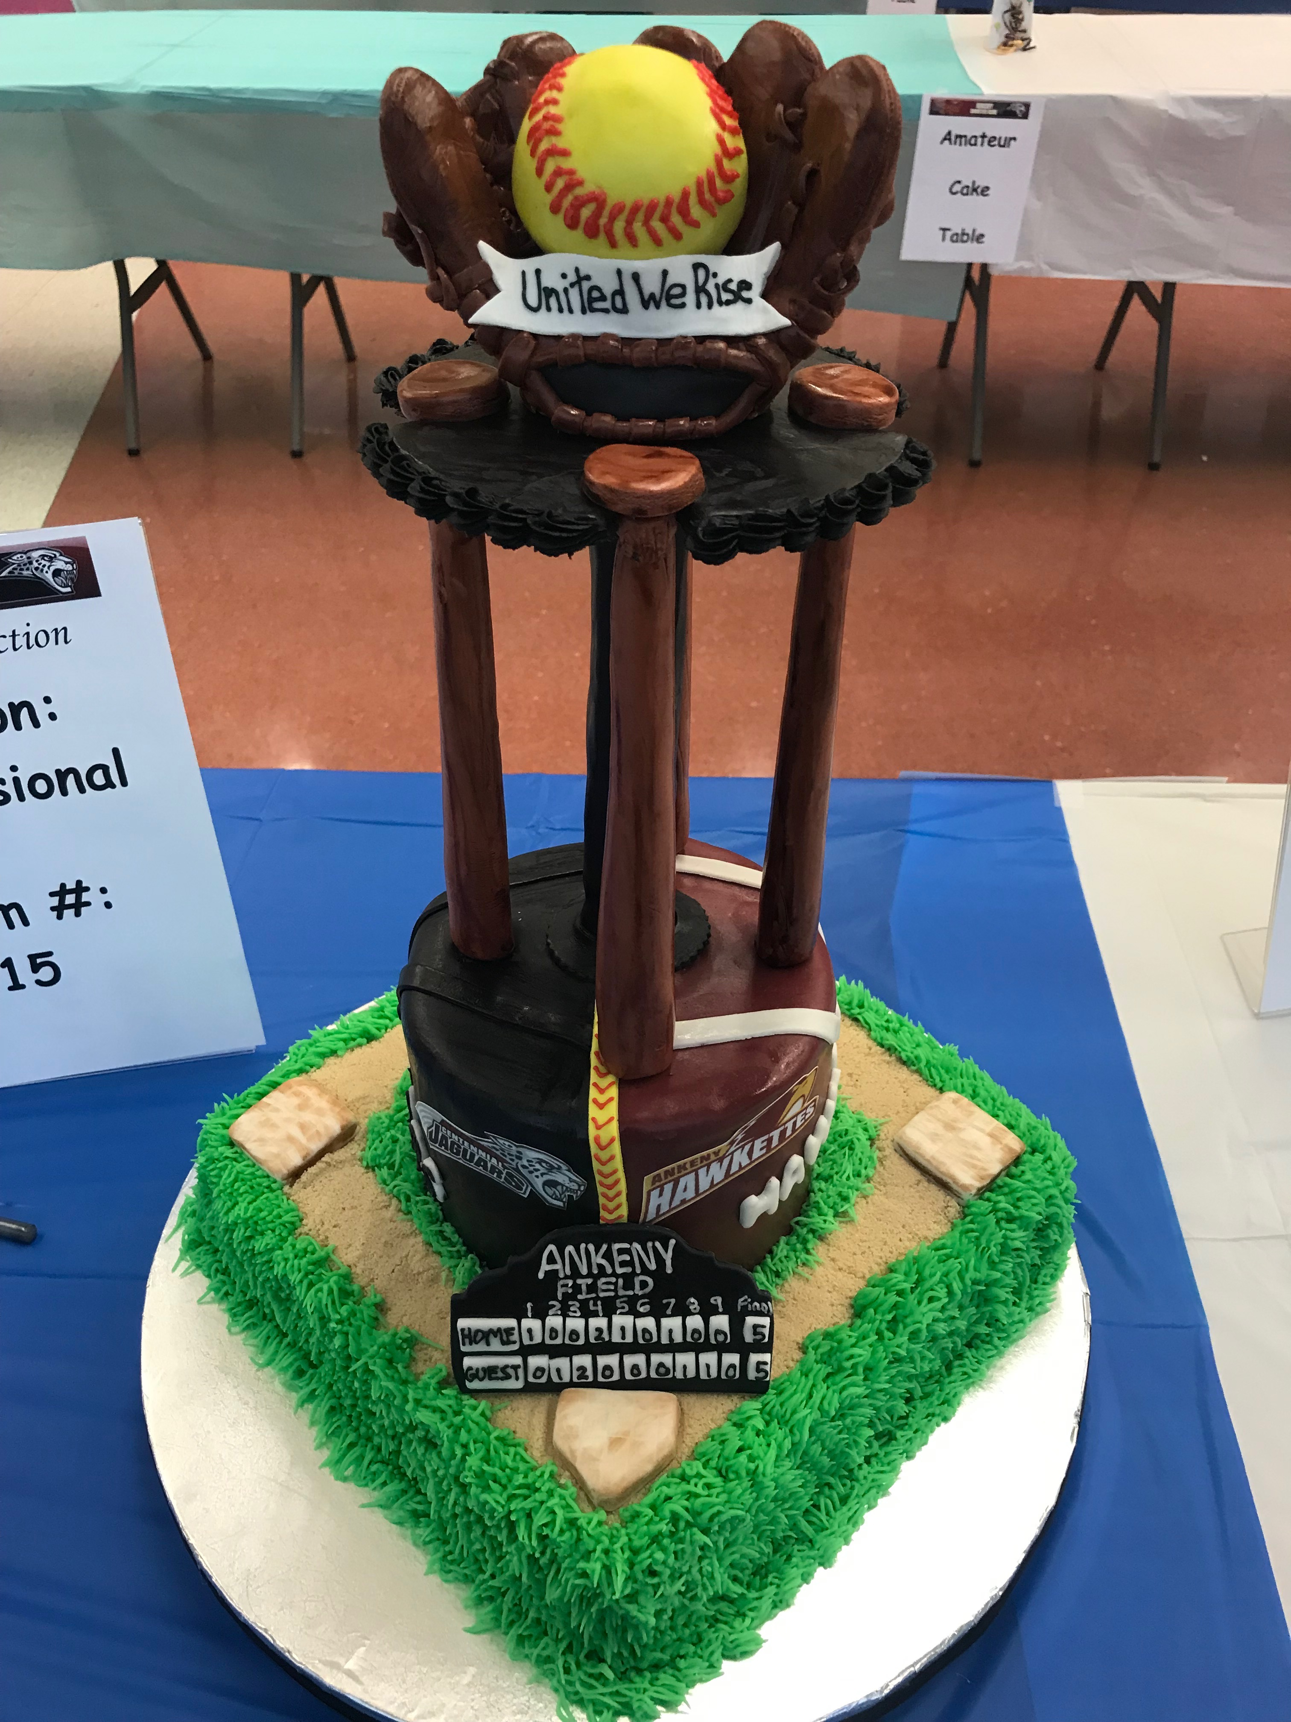
- BIDDERS DRIVE THIS AUCTION…..ASK BUSINESS LEADERS TO COME BID ON YOUR CAKE!!
DIRECT QUESTIONS TO BRENT BUTTJER, DC-G ACTIVITIES DIRECTOR

